**GT**

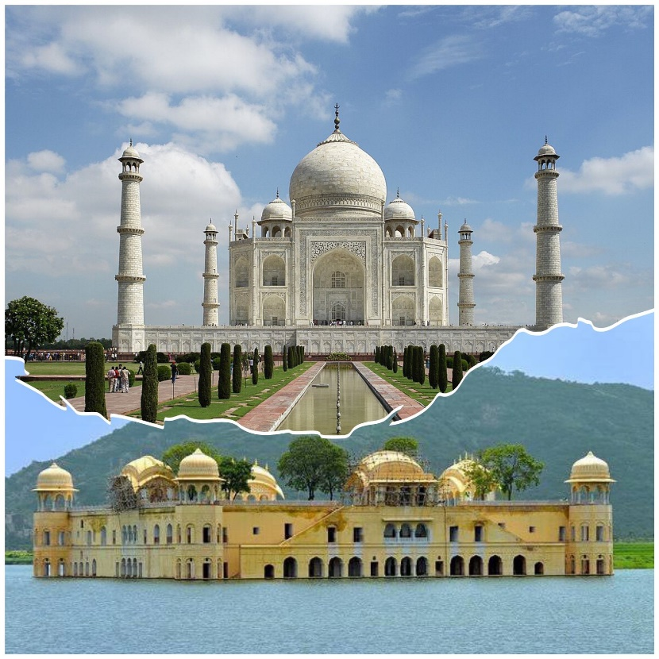

**-Agra Jaipur Tour Package**

02 Nights / 03 Days

Starting from 7000 per person

**Inclusion**

01 Night stay in Agra

01 Nights stay in Jaipur

Welcome Drink On Arrival

02 Breakfast and 02 Dinner

Pickup / drop Ex. Delhi

Driver Allowances

All Toll taxes, state taxes, Parking and fuel cost

All Transfers & Sightseeing by cab

Sightseeing spots:- Taj Mahal, Agra Fort, Amber fort, Jal Mahal, Hawa Mahal and Local markets

**Exclusion**

5% Gst Extra

All personal expenses, optional tours and extra meals

Camera fees, alcoholic/non-alcoholic beverages, mineral water and starters

Entrance fees at all monuments and museums or guide charges mentioned in the itinerary

Medical and travel insurance

Anything not mentioned under ‘Package Inclusions’

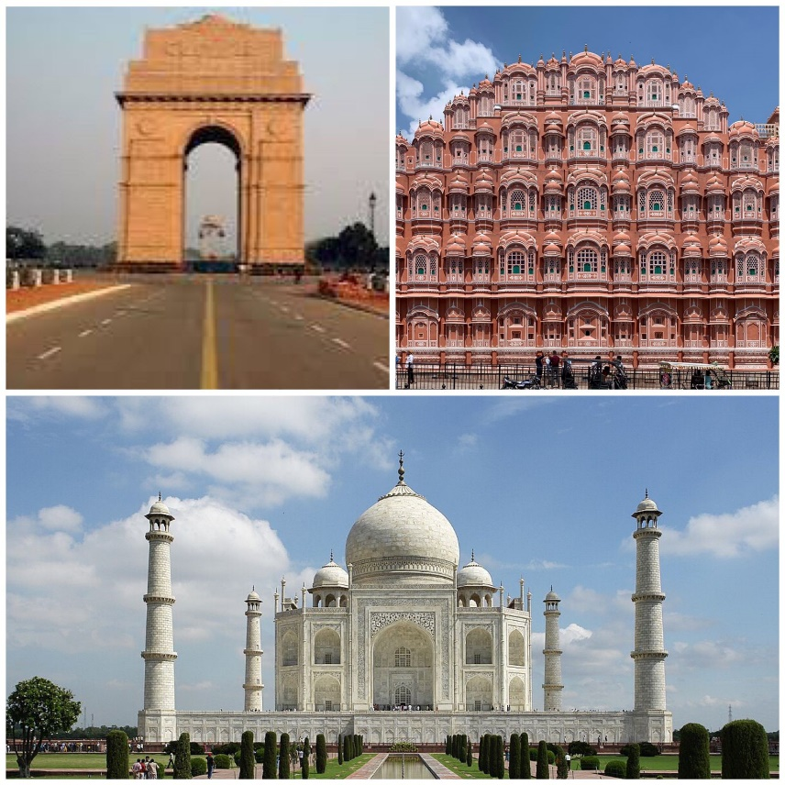

**-Golden Triangle tour package**

03 Nights / 04 Days

Starting from  9000 per person

**Inclusion**

01 Night stay in Delhi

01 Night stay in Agra

01 Nights stay in Jaipur

Welcome Drink On Arrival

03 Breakfast and 03 Dinner

Pickup / drop Ex. Delhi

Driver Allowances

All Toll taxes, state taxes, Parking and fuel cost

All Transfers & Sightseeing by cab

Sightseeing spots:- India Gate, Red Fort, Jama Masjid, Akshardham Temple, Taj Mahal, Agra Fort, Fatehpur Sikri, Amber fort, Jal Mahal, Hawa Mahal and Local markets

**Exclusion**

5% Gst Extra

All personal expenses, optional tours and extra meals

Camera fees, alcoholic/non-alcoholic beverages, mineral water and starters

Entrance fees at all monuments and museums or guide charges  mentioned in the itinerary

Medical and travel insurance

Anything not mentioned under ‘Package Inclusions’

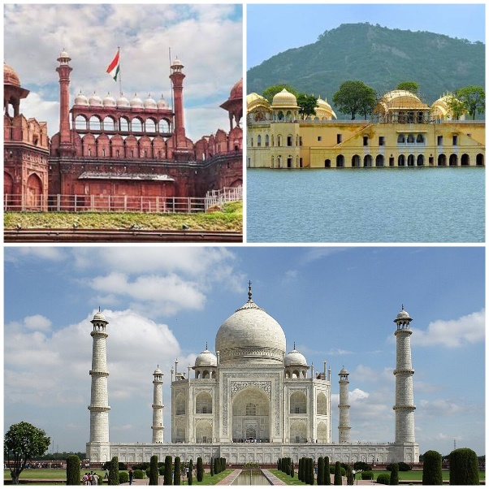

**-India’s magic golden triangle tour package**

03 Nights / 04 Days

Starting from 9000 per person

**Inclusion**

01 Night stay in Delhi

01 Night stay in Agra

01 Nights stay in Jaipur

Welcome Drink On Arrival

03 Breakfast and 03 Dinner

Pickup / drop Ex. Delhi

Driver Allowances

All Toll taxes, state taxes, Parking and fuel cost

All Transfers & Sightseeing by cab

Sightseeing spots:- India Gate, Red Fort, Jama Masjid, Akshardham Temple, Taj Mahal, Agra Fort, Fatehpur Sikri, Amber fort, Jal Mahal, Hawa Mahal and Local markets

**Exclusion**

5% Gst Extra

All personal expenses, optional tours and extra meals

Camera fees, alcoholic/non-alcoholic beverages, mineral water and starters

Entrance fees at all monuments and museums or guide charges  mentioned in the itinerary

Medical and travel insurance

Anything not mentioned under ‘Package Inclusions’

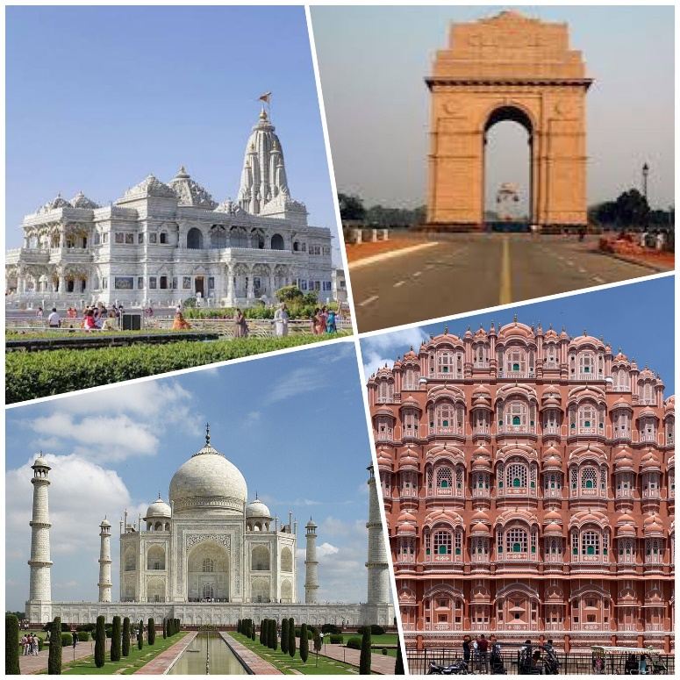

**-Golden Triangle with Mathura / Vrindavan tour package**

03 Nights / 04 Days

Starting from 9500 per person

**Inclusion**

01 Night stay in Delhi

01 Night stay in Agra

01 Nights stay in Jaipur

Welcome Drink On Arrival

03 Breakfast and 03 Dinner

Pickup / drop Ex. Delhi

Driver Allowances

All Toll taxes, state taxes, Parking and fuel cost

All Transfers & Sightseeing by cab

Sightseeing spots:- India Gate, Red Fort, Jama Masjid, Akshardham Temple, Banke Bihari Temple, Iskon Temple, Prem Mandir,Taj Mahal, Agra Fort, Fatehpur Sikri, Amber fort, Jal Mahal, Hawa Mahal and Local markets

**Exclusion**

5% Gst Extra

All personal expenses, optional tours and extra meals

Camera fees, alcoholic/non-alcoholic beverages, mineral water and starters

Entrance fees at all monuments and museums or guide charges  mentioned in the itinerary

Medical and travel insurance

Anything not mentioned under ‘Package Inclusions’



**-Exotic Golden Triangle Tour Package**

03 Nights / 04 Days

Starting from 9000 per person

**Inclusion**

01 Night stay in Delhi

01 Night stay in Agra

01 Nights stay in Jaipur

Welcome Drink On Arrival

03 Breakfast and 03 Dinner

Pickup / drop Ex. Delhi

Driver Allowances

All Toll taxes, state taxes, Parking and fuel cost

All Transfers & Sightseeing by cab

Sightseeing spots:- India Gate, Red Fort, Jama Masjid, Akshardham Temple, Taj Mahal, Agra Fort, Fatehpur Sikri, Amber fort, Jal Mahal, Hawa Mahal and Local markets

**Exclusion**

5% Gst Extra

All personal expenses, optional tours and extra meals

Camera fees, alcoholic/non-alcoholic beverages, mineral water and starters

Entrance fees at all monuments and museums or guide charges  mentioned in the itinerary

Medical and travel insurance

Anything not mentioned under ‘Package Inclusions’

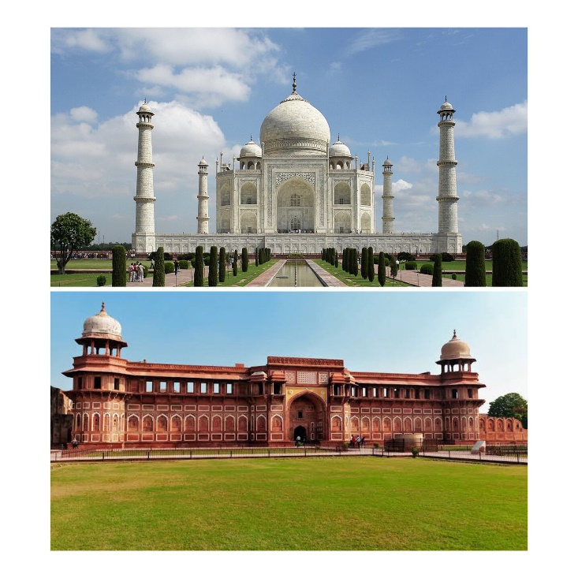

**- Weekend Agra Tour Package**

01 Night / 02 Days

Starting from 4500 per person

**Inclusion**

01 Night stay in Agra

Welcome Drink On Arrival

01 Breakfast and 01 Dinner

Pickup / drop Ex. Delhi

Driver Allowances

All Toll taxes, state taxes, Parking and fuel cost

All Transfers & Sightseeing by cab

Sightseeing spots:- Taj Mahal, Agra Fort and Local markets

**Exclusion**

5% Gst Extra

All personal expenses, optional tours and extra meals

Camera fees, alcoholic/non-alcoholic beverages, mineral water and starters

Entrance fees at all monuments and museums or guide charges  mentioned in the itinerary

Medical and travel insurance

Anything not mentioned under ‘Package Inclusions’



**-Agra Day Tour Package**

01 Day

Starting from 2500 per person

**Inclusion**

Pickup / drop Ex. Delhi

Driver Allowances

All Toll taxes, state taxes, Parking and fuel cost

All Transfers & Sightseeing by cab

Sightseeing spots:- Taj Mahal, Agra Fort and Local markets

**Exclusion**

5% Gst Extra

All personal expenses, optional tours and extra meals

Camera fees, alcoholic/non-alcoholic beverages, mineral water and starters

Entrance fees at all monuments and museums or guide charges  mentioned in the itinerary

Medical and travel insurance

Anything not mentioned under ‘Package Inclusions’



**- Majestic Agra Tour package**

01 Night / 02 Days

Starting from 4500 per person

**Inclusion**

01 Night stay in Agra

Welcome Drink On Arrival

01 Breakfast and 01 Dinner

Pickup / drop Ex. Delhi

Driver Allowances

All Toll taxes, state taxes, Parking and fuel cost

All Transfers & Sightseeing by cab

Sightseeing spots:- Taj Mahal, Agra Fort and Local markets

**Exclusion**

5% Gst Extra

All personal expenses, optional tours and extra meals

Camera fees, alcoholic/non-alcoholic beverages, mineral water and starters

Entrance fees at all monuments and museums or guide charges  mentioned in the itinerary

Medical and travel insurance

Anything not mentioned under ‘Package Inclusions’

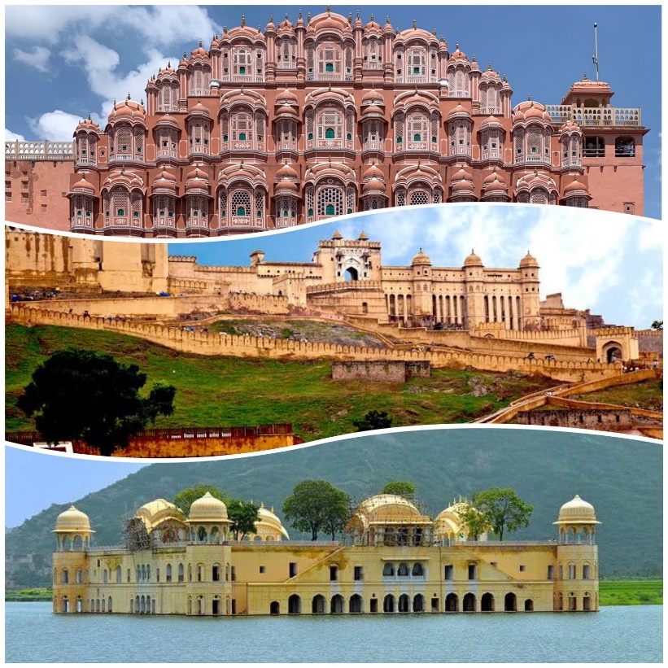

**- Jaipur Pink city tour package**

02 Night / 03 Days

Starting from 6000 per person

**Inclusion**

02 Nights stay in Jaipur

Welcome Drink On Arrival

02 Breakfast and 02 Dinner

Pickup / drop Ex. Delhi

Driver Allowances

All Toll taxes, state taxes, Parking and fuel cost

All Transfers & Sightseeing by cab

Sightseeing spots:- Amber fort, Jal Mahal, Hawa Mahal, Jantar Mantar and Local markets

**Exclusion**

5% Gst Extra

All personal expenses, optional tours and extra meals

Camera fees, alcoholic/non-alcoholic beverages, mineral water and starters

Entrance fees at all monuments and museums or guide charges  mentioned in the itinerary

Medical and travel insurance

Anything not mentioned under ‘Package Inclusions’

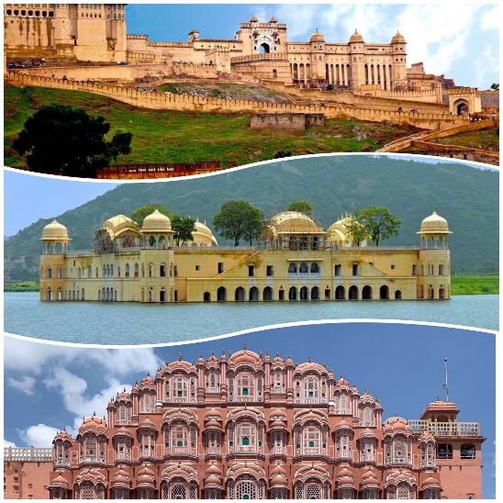

**-Weekend Jaipur tour package**

01 Night / 02 Days

Starting from 4500 per person

**Inclusion**

01 Night stay in Jaipur

Welcome Drink On Arrival

01 Breakfast and 01 Dinner

Pickup / drop Ex. Delhi

Driver Allowances

All Toll taxes, state taxes, Parking and fuel cost

All Transfers & Sightseeing by cab

Sightseeing spots:- Amber fort, Jal Mahal, Hawa Mahal, Jantar Mantar and Local markets

**Exclusion**

5% Gst Extra

All personal expenses, optional tours and extra meals

Camera fees, alcoholic/non-alcoholic beverages, mineral water and starters

Entrance fees at all monuments and museums or guide charges  mentioned in the itinerary

Medical and travel insurance

Anything not mentioned under ‘Package Inclusions’

NOTE:- The above mentioned packages are the standard packages. We can customize your tour as per your preferences to make your travel more comfortable and memorable.